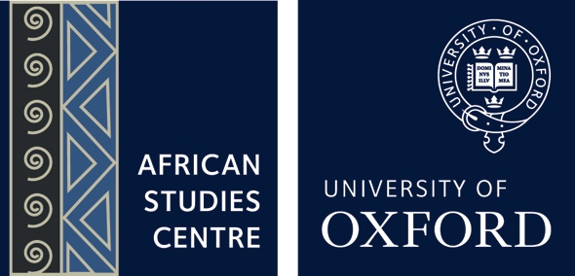
African Studies Seminar
Hilary Term 2020, Thursdays, 3pm
Dahrendorf & Deakin Rooms (St Antony’s College)

23 January  (Week 1) | Book Launch: Extralegal Groups in Post-Conflict Liberia  (Winner of the 2019 Conflict Research Society Book of the Year)  Speaker: Christine Cheng (War Studies Department, King’s College London)  Venue: Dahrendorf Room
30 January  (Week 2) | Book Launch: The Army and Politics in Zimbabwe: Solomon Mujuru, the Liberation Fighter and Kingmaker  Speaker: Miles Tendi (ASC & DPIR, University of Oxford)  Venue: Deakin Room
6 February  (Week 3) | Can Technology Facilitate Justice for Crimes Against Humanity? A Case Study on Digital Evidence in the DRC  Speaker: Raquel Vazquez Llorente (Law Faculty, University of Oxford)  Venue: Dahrendorf Room
13 February  (Week 4) | Mozambique Elections 2019: Pernicious Polarization and Democratic Decline  Speaker: Anne Pitcher (Political Science Department, University of Michigan)  Venue: Dahrendorf Room
20 February  (Week 5) | Researching Africa at the Foreign & Commonwealth Office: Impact, Analysis and Challenges  Speakers: Sara Rich Dorman (Politics and International Relations Department, University of Edinburgh & ESRC-AHRC-FCO Knowledge Exchange Fellow, 2018-2020) and Owen Elliott (Research leader of the Southern, Central & Lusophone Africa team in the FCO’s Africa Research Group)  Venue: Dahrendorf Room
27 February  (Week 6) | Nairobi in the Making: Landscape, Time and Urban Belonging  Speaker: Constance Smith (Social Anthropology Department, University of Manchester)  Venue: Dahrendorf Room
5 March  (Week 7) | Political Economists, Dollars and the Strategic Power of Business in Sudan  Speaker: Alden Young (African American Studies Department, University of California, Los Angeles)  Venue: Dahrendorf Room
12 March  (Week 8) | Broken Cities: an Africanist View on the Global Housing Affordability Crisis  Speaker: Deborah Potts (Emeritus Reader, King’s College London)  Venue: Deakin Room

